###### Shell Programming: Shell Scripts

**Subject:- Unix Operating System System Lab Class :- TYIT**

**Name: - SHRENIK JADHAV**

**OM GHARGE**

**PRN: -2020BTEIT00011,2020BTEIT00041**

**Assignment No** - **5a**

**Title-**Write a program to implement a shell script for calculator

**Objectives –**

1. To learn shell programming and use it for write effective programs.

**Theory-**

A shell in a Linux operating system takes input from you in the form of commands, processes it, and then gives an output. It is the interface through which a user works on the programs, commands, and scripts. A shell is accessed by a terminal which runs it.

When you run the terminal, the Shell issues a command prompt (usually $), where you can type your input, which is then executed when you hit the Enter key. The output or the result is thereafter displayed on the terminal.

The Shell wraps around the delicate interior of an Operating system protecting it from accidental damage. Hence the name Shell.

**Flowchart-**

start

Read

number

and operator

Print result

stop

Compute operation

**Program-**

#!/bin/bash

# Function to perform addition

addition() {

echo "Enter the first number: "

read num1

echo "Enter the second number: "

read num2

sum=$((num1 + num2))

echo "The sum of $num1 and $num2 is $sum."

}

# Function to perform subtraction

subtraction() {

echo "Enter the first number: "

read num1

echo "Enter the second number: "

read num2

diff=$((num1 - num2))

echo "The difference between $num1 and $num2 is $diff."

}

# Function to perform multiplication

multiplication() {

echo "Enter the first number: "

read num1

echo "Enter the second number: "

read num2

product=$((num1 * num2))

echo "The product of $num1 and $num2 is $product."

}

# Function to perform division

division() {

echo "Enter the numerator: "

read num1

echo "Enter the denominator: "

read num2

if [ $num2 -eq 0 ]

then

echo "Error: Division by zero."

elsequotient=$((num1 / num2))

echo "The quotient of $num1 and $num2 is $quotient."

fi

}

# Main program

echo "Calculator Menu:"

echo "1. Addition"

echo "2. Subtraction"

echo "3. Multiplication"

echo "4. Division"

echo "Enter your choice (1-4): "

read choice

case $choice in

1) addition ;;

2) subtraction ;;

3) multiplication ;;

4) division ;;

*) echo "Error: Invalid choice." ;;

esac

run

--

* Save the file with a .sh extension, for example, calculator.sh.
* Open a terminal on your Ubuntu system.
* Navigate to the directory where you saved the Bash script using the cd command. For example, if you saved the script in your home directory, you can use the following command:

bash

* cd ~
* Make the script file executable by running the following command:

bash

* chmod +x calculator.sh

This command grants execute permissions to the script file.

* Run the Bash script by entering the following command:

bash

* ./calculator.sh

This command executes the script and starts the calculator program.

* You will see a calculator menu with options for addition, subtraction, multiplication, and division.
* Enter the number corresponding to your desired operation (1-4) and press Enter.
* Follow the prompts to enter the required numbers for the chosen operation.
* The script will perform the calculation and display the result.
* You can continue using the calculator by selecting another operation or enter an invalid choice to exit the program.

**Output-**

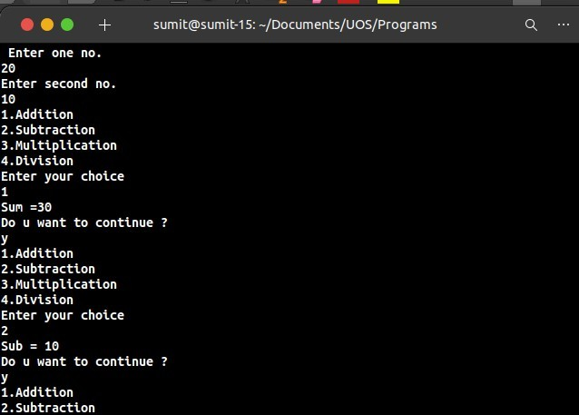

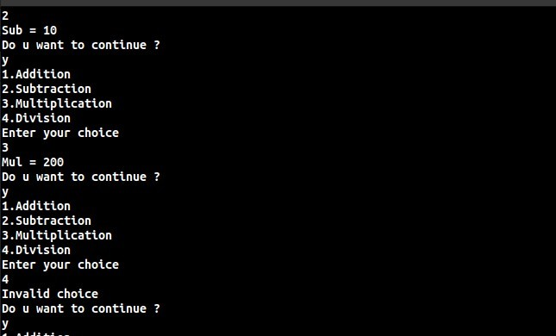

**Conclusion:**

Calculator constructed using shell programming

**References:**

**https://**[**www.tutorialspoint.com/unix/unix-what-is-shell.htm/**](http://www.tutorialspoint.com/unix/unix-what-is-shell.htm/)